2009 APHAFIC Winter Meeting.

The APHAFIC winter meeting was held at China Max restaurant on January 14th. We had a total of 52 attendees including many friends of our members. After the delicious dinner, Nancy Lo introduced Rev. Yoshikuni Kaneda, a long time member of APHAFIC. He was the winner of Iris Chang memorial fund essay contest 2007. The topic of his speech was "Japan Report: Focusing on Japanese Racism Caused by the Emperor System". Two of his primary references were “Hirohito and the making of the modern Japan”, by Herbert P Bix, and “Embracing defeat: Japan in the wake of World War II” by John W Dower. Both authors were Pulitzer prize winners. Rev Kaneda showed the status of the emperor with a sharp contact between the constitution of the empire of Japan in Meiji constitution, 1889 and postwar constitution, 1946. However, he indicated that the emperor worship has gradually come back to Japan.

Rev Kaneda quoted from the book “Rising Sun” by Michael Crichton who stated that the Japanese are the most racist people on earth and said it was their racism that causes the superior complex against foreigners. Rev Kaneda also believes that Japan’s racism is solely based on the belief in the myth of the emperor system even though Japanese are actually a mixed race, not a ‘pure’ blooded Yamato tribe and not as homogeneous as they want to believe. They are the mixed blood race of Mongolians, Chinese, Koreans, Southwest Asians and South Pacific Islanders. As the emperor still is the most powerful symbol and the living idol of Japan, Rev. Kaneda thinks it would be effective for the emperor to encourage Japan to own up to all of the past history.

Rev Kaneda took a trip to Japan in October 8-26 2008 and gave lectures about his thoughts on ‘Why did the Japanese Imperial Army commit atrocities such as the Nanking massacre?’ to various groups for about 400 people. Their reactions varied: courteous and polite, as they did not speak up any negative comments toward him. He noticed that speaking against the emperor system in Japan still offended some folks there. Heartwarming responses came from the college students and church groups. Rev Kaneda will continue his speech on what he believes is the primary cause for the atrocity during WWII, i.e. the misplaced loyalty with racism. He is willing to outreach to local schools.
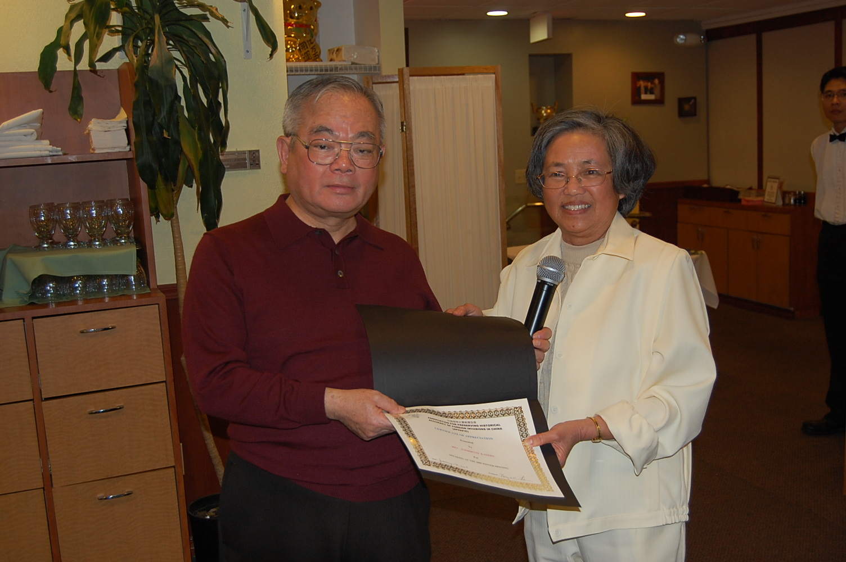

Nancy Lo presented a certificate of appreciation to Rev Kaneda

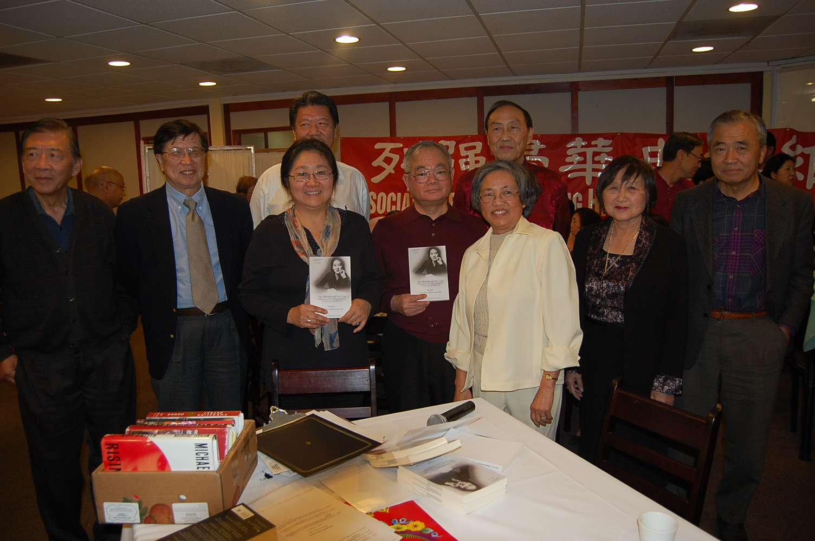
Rev Kaneda with the APHAFIC board members. Mary Yan-Lee’s (holding the essay book) essay was one of the essays of Distinction in the book: The denial and its cost: reflections on Nanking Massacre 70 years ago and beyond.

